Project Design Phase-II Technology Architecture of the Solution

|  |  |
| --- | --- |
| Date | 15 October 2022 |
| Team ID | PNT2022TMID42262 |
| Project Name | Personal Assistance for Seniors Who Are Self-Reliant |
| Maximum Marks | 4 Marks |

Technology Architecture:

The Deliverable shall include the architectural diagram as below and the information as per the table1 & table 2

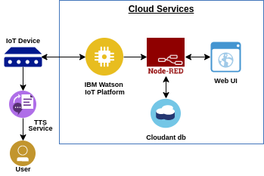

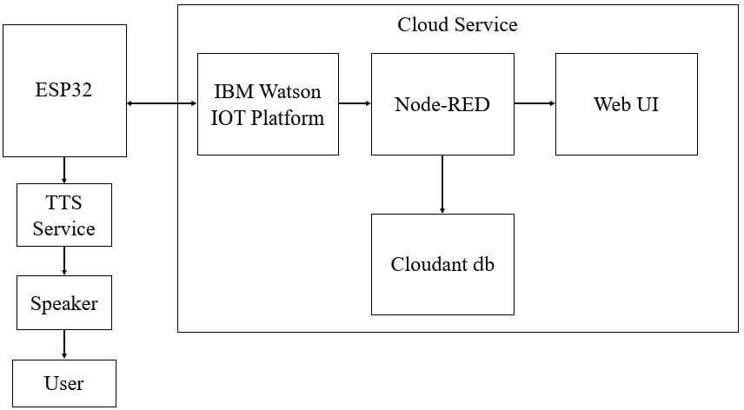

Table-1: Components & Technologies:

|  |  |  |  |
| --- | --- | --- | --- |
| **S.No** | **Component** | **Description** | **Technology** |
| 1. | User Interface | Web UI or Mobile application. | HTML, JavaScript |
| 2. | Application Logic-1 | Web UI app or Mobile app to enter the user details and medicine details. | Python |
| 3. | Application Logic-2 | Getting the medication details from the database | IBM Watson STT service |
| 4. | Application Logic-3 | Text to Speech service is provided and also access the Speech to Text feature. | IBM Watson Assistant |
| 5. | Cloud Database | The User login credentials and the medication details such as time & dosage are updated. | IBM Cloudant |

|  |  |  |  |
| --- | --- | --- | --- |
| 6. | File Storage | API key, user medication reports, login credentials, IOT credentials, previous medication records. | IBM Block Storage |
| 7. | External API-1 | To locate the IOT device to be monitored 24/7 and records the data properly. | IBM Geolocation  API |
| 8. | External API-2 | The user interface for the login credentials. | Username & Password API. |
| 9. | Infrastructure (Server / Cloud) | Act as a host for the server and the application. | Cloud Foundry |

Table-2: Application Characteristics:

|  |  |  |  |
| --- | --- | --- | --- |
| **S.No** | **Characteristics** | **Description** | **Technology** |
| 1. | Open-Source Frameworks | To develop the application interface for the user. | MIT App Inventor |
| 2. | Security Implementations | Major security to the users’:  Personal information, login credentials, previous data records. | SHA-256, Encryptions, OWASP. |
| 3. | Scalable Architecture | To the maximum extent the database can be scaled in the IBM database. | IBM Auto Scaling |
| 4. | Availability | 24/7 services and make sures the app is very reliable and data retrievability is available anytime without any loss in information. | IBM Cloud Load Balancer |
| 5. | Performance | Easily scalable design so the performance of the application is very in every instances and the allows the maximum number of users at a time. | IBM Instance |